From http://www.presstv.ir/detail/2014/10/07/381326/washington-is-destroying-the-world/

Washington is destroying the world

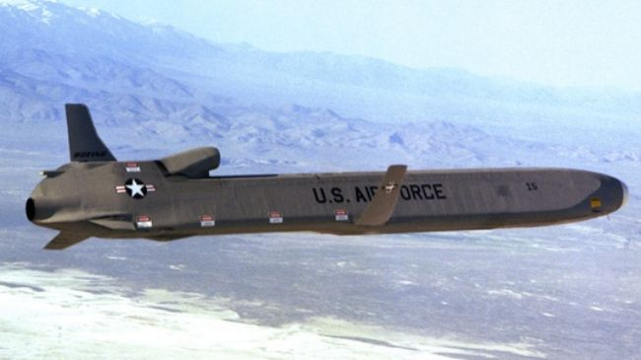
Paul Craig Roberts says restarting the US-Russian arms race is essential to the profits of the US military/security complex and to the campaign contributions of senators.

Paul Craig Roberts, paulcraigroberts.org
Tue Oct 7, 2014 5:18AM GMT
The aggressive and mindless stance that Washington’s warmongers have taken toward Russia and China has shattered the accomplishment of Reagan and Gorbachev.
Reagan and Gorbachev ended the Cold War and removed the threat of nuclear Armageddon. Now the neocons, the US budget-dependent (taxpayer dependent) US military/security complex, and the US politicians dependent on campaign funds from the military/security complex have resurrected the nuclear threat.
The corrupt and duplicitous Clinton regime broke the agreement that the George H.W. Bush administration gave Moscow in 1990. In exchange for Moscow permitting a reunified Germany to be a NATO member, Washington agreed that there would be no expansion of NATO to the east. Gorbachev, US Secretary of State James Baker, US Ambassador to Moscow Jack Matlock, and declassified documents all testify to the fact that Moscow was assured that there would be no expansion of NATO into Eastern Europe.
In 1999, President Bill Clinton made a liar of the administration of President George H.W. Bush. The corrupt Clinton brought Poland, Hungary, and the newly formed Czech Republic into NATO.
President George W. Bush also made a liar out of his father, George H.W. Bush, and his father’s trusted Secretary of State, James Baker. “Dubya,” as the fool and drunkard is known, brought Estonia, Latvia, Lithuania, Slovenia, Slovakia, Bulgaria, and Romania into NATO in 2004. The corrupt and hopeless Obama regime added Albania and Croatia in 2009.
In other words, over the past 21 years three two-term US presidents have taught Moscow that the word of the US government is worthless.
Today Russia is surrounded by US and NATO military bases, with more to come in Ukraine (part of Russia for centuries), Georgia (part of Russia for centuries and the birthplace of Joseph Stalin), Montenegro, Macedonia, Bosnia-Herzegovina, and perhaps also Azerbaijan.
A large land expanse that was formerly part of the Soviet Empire is now part of Washington’s Empire. The “coming of democracy” simply meant the changing of masters.
Washington always picks the puppet who serves as Secretary General of NATO. The latest is a former Norwegian politician and prime minister, Jens Stoltenberg. On Washington’s orders, the puppet quickly antagonized Moscow with the statement that NATO has a powerful army that has a global policing role and can be deployed wherever Washington wishes. This claim is a total contradiction of NATO’s purpose and charter.
Igor Korochenko, a member of the Russian Defense Ministry Public Council replied to Washington’s puppet Stoltenberg: “Such statements run counter to the system of international security, as the NATO alliance poses a threat to Russia. Therefore, it will cause responsive measures.”
The responsive measures are what you would expect: enough nuclear capability to wipe out the United States and Europe many times over.
The arrogant fools in Washington, wallowing in their hubris as “the indispensable nation,” have provoked Moscow to the point that Russia now has more deployed nuclear weapons than the US. As a result of Washington breaking its word and putting ABM missile bases on Russia’s border, Russia has developed supersonic ICBMs that can rapidly change their trajectory and cannot be shot down by any missile defense system. Of course, the US corporations making billions of dollars selling Washington a useless ABM system will deny this.
Moreover, those countries, such as Poland, whose governments are sufficiently stupid to accept US ABM bases, would be obliterated before the bases could function. The utter stupidity of Eastern Europe’s bought-and-paid-for governments to put trust in Washington is likely to be the main cause of WW III.
The happy participant in the new Armageddon is the American military/security complex. These greedy b**tards – “private corporations” whose revenues are entirely public funds – are guaranteed more money regardless of the potential cost in human life. Their US Senate spokesperson, Jim Inhofe, a member of the Senate Armed Services Subcommittee on Strategic Forces, has resurrected the argument from 60 years ago that America is falling behind in the arms race. Restarting the arms race is essential to the profits of the US military/security complex and to the campaign contributions of senators.
It is not only Russia’s strategic nuclear forces that the fools in Washington have revived and activated, but China’s as well. Last year China released a pictorial description of how China’s nuclear forces could destroy the US. This was China’s response to Washington’s insane plan of building new air and naval bases from the Philippines to Vietnam in order to control the flow of resources in the South China Sea. What kind of idiotic government does America have that thinks China is going to put up with this kind of interference in China’s sphere of influence?
China has now added to its nuclear arsenal a new variant of one of its mobile ICBMs. Washington does not know much about this new missile, because the CIA is too busy arranging protests in Hong Kong.
Both Russia and China were content to be part of the world economy and to improve the economic situation of their citizens by developing their economies. But along comes the neocon Unipower, a collection of arrogant psychopaths who declare that Washington will not permit any other country, not even Russia and China, to rise to a capability of exercising a foreign policy independent of Washington’s purposes. [The “Wolfowitz Doctrine”. –FNC]
Nuclear war is back into the picture. First Washington threatens those it perceives as rivals. When the perceived rivals do not submit, Washington demonizes them.
In the histories written by Washington’s court historians, the greatest demons of modern times are the WW II governments of Japan and Germany along with the post-WW II Soviet government of Joseph Stalin. These American court historians ignore the facts.
Japan was forced into war by Washington, which cut off Japan’s access to resources. Japan was then nuked twice while the Japanese government was trying to surrender.
All of US President Woodrow Wilson’s promises made to Germany in order to end WW I, such as no territorial loses and no reparations, were broken. Germany was torn apart and German territory was handed over to Poland, France, and Czechoslovakia. Despite US President Woodrow Wilson’s promise to the contrary, impossible reparations were imposed on Germany by the Treaty of Versailles. The prescient John Maynard Keynes declared that the reparations would result in a second world war. If memory serves, portions of Germany were also given to Belgium, Lithuania, and Denmark.
This humiliation of an industrious and powerful people, whose armies occupied foreign territories when WW I ended, demonstrated the mendacity of the so-called “Western powers.” The French, British, and Americans paved the way for Adolph Hitler. By 1935 Hitler was sufficiently ensconced to denounce the Versailles Treaty. If Hitler had not succumbed to hubris and sent the German armies marching off into Russia where they were destroyed, he, or his successors, would still be ruling Europe today.
The true history is so different from what Washington pretends and Americans are taught. The majority of Americans are blind enablers of Washington’s war on the world. If Ebola and global warming do not destroy humanity, the ignorance of the American people and Washington’s war for world hegemony surely will.
Paul Craig Roberts is a former Assistant Secretary of the US Treasury and Associate Editor of the Wall Street Journal. His latest book is How America Was Lost.
GJH/GJH

